Xuecong Fan

A01972388

Assign 4, part I

1. Figure 1 is both. Figure 2 just a binary search tree.
2. 30. Left right rotation. 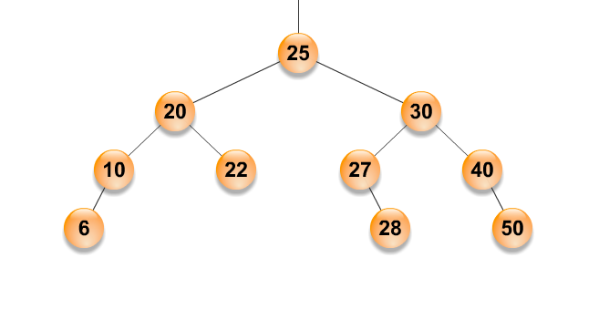
3. 40. Right right rotation.

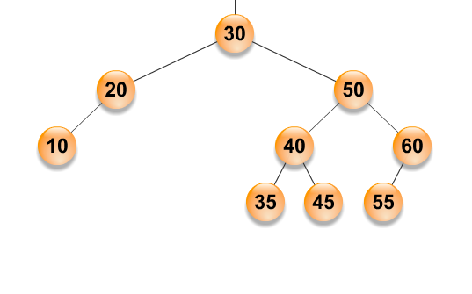

4)After delete 30.

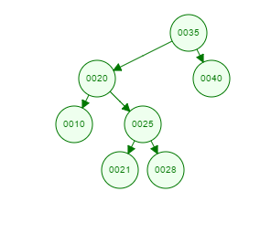

After Left right rotation.

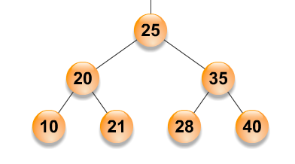

5)

After delete 20.

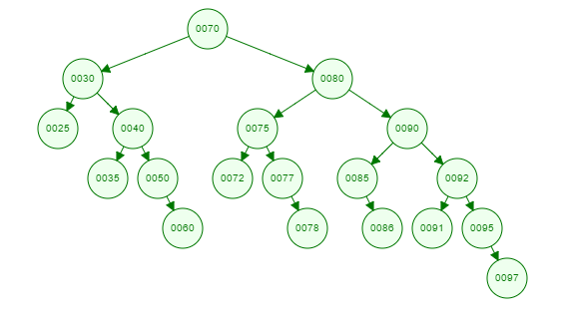

Right right rotation first.

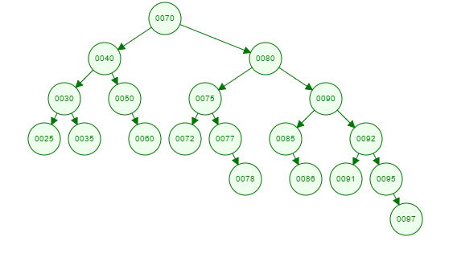

Right right rotation second.

